**National Institute of Technology Raipur**

**Group No……..**

PHYSICS -II LABORATORY MANUAL



**DEPARTMENT OF PHYSICS**

**National Institute of Technology Raipur**

|  |  |
| --- | --- |
| **Name** |  |
| **Branch & Section** |  |
| **Roll. No.** |  |

**‘General Instructions**

1. Each practical class will be divided into number of batches consisting of at least four students.
2. Every batch/class will perform one practical on each turn.
3. **Each student shall have to perform in general 10 experiments in cyclic chronological order & one project work. Each student will know on its first turn-which set of 10 experiments it is required to perform in that semester**.
4. Procedure of cyclic rotation will be strictly followed irrespective of the fact whether allotted experiment could be completed or not and whether a student was present or absent in the previous class.
5. Practical Record Book will be submitted in the lab positively before getting the apparatus issued. Attendance is marked on the basis of record books deposited. Hence, do not forget to submit record book immediately after entering the lab.
6. When the name of particular student is called, he/she and his/her partner will present himself to the professor along with their preparation note books for checking of their practical record books.
7. Calculation must be done separately on the left page of the record book by substituting various observed values in the formula for each set of observations.
8. Keep various items of any experiment in the same order as shown in the circuit diagram. Initially all keys should be kept open. Thereafter, connections should be made selecting wires of appropriate length.
9. Every measuring instrument has a least count. Find it and measure up to the desired place accurately and record accordingly.
10. Disconnect the apparatus and do return the issued material at the counter before leaving the laboratory.

**NATIONAL INSTITUTE OF TECHNOLOGY RAIPUR**

Phone : (0771)2243413

Fax : (0771) 2254600

Email : **phy.dpt.nitrr@gmail.com**

Website : **www.nitrr.ac.in**

(Institute of National Importance)

G.E. Road Raipur (C.G.)

**Effective from – DEC. 2019**

**Department of Physics**

Physics-II Laboratory

**Part – A**

**List of Projects**

1. (A) To verify the truth tables of basic and universal logic gates (OR, AND, NOT, NOR and NAND) and verification of De Morgan’s theorems.

(B) To study the properties of universal gates and construct the following

Gates.

(i) AND, OR and NOT gate using NAND gate.

(ii) AND, OR and NOT gate using NOR gate.

1. To determine the resistivity and band-gap value of a semiconductor material by four probes technique.
2. To study the Hall Effect and to determine the Hall Coefficient (RH).
3. To study the various characteristics of a Light Emitting Diode (LED)
4. To determine the width of the forbidden energy-gap of a semiconductor material taken in the form of a p-n junction diode.
5. To study the different operations of an ALU (Arithmetic Logic Unit).
6. To study the V-I characteristics of a solar cell.

**Part - B**

**List of Experiments**

1. To study the input and output characteristics, and to calculate the h - parameters of a PNP transistor in CE mode.
2. To study the conversion of digital signals in to analog signals using digital to analog (D/A) converter.
3. To study the drain and transfer characteristics of a Field effect Transistor (FET).
4. To study the output and transfer characteristics of a Metal Oxide Silicon Field Effect Transistor (MOSFET) and to identify the type of MOSFET.
5. To study the V-I characteristics of a Unijunction transistor (UJT).
6. To study conversion of analog signals in to digital signals using analog to digital (A/D) converter.
7. (A)To study the working of a Hartley oscillator using a transistor and to determine its frequency of oscillations and compare it with theoretical value.

(B) To study of the wave shape and frequency of signals produced by a Colpitt’s oscillator.

1. To study the following applications of an OP-AMP:

(a) Inverting (b) Non-inverting

(c) Summing (d) Differentiator

1. To study the functioning of lamp block and characteristics of a Photo transistor/ Photo diode.
2. To study the output gain, output power and frequency response of a Push-Pull amplifier.

**Index**

|  |  |  |  |  |  |  |
| --- | --- | --- | --- | --- | --- | --- |
| **Sr.No.** | **Title of the Experiment** | **Page No.** | **Date of**  **Performing Experiment** | **Date of Submission/correction** | **Grade obtained (Max. 10)** | **Remarks** |
| **1.** | **To study the input and output characteristics, and to calculate the h - parameters of a PNP transistor in CE mode.** |  |  |  |  |  |
| **2.** | **To study conversion of digital signals in to analog signals using (D/A) converter.** |  |  |  |  |  |
| **3.** | **To study the drain and transfer characteristics of a Field effect Transistor (FET).** |  |  |  |  |  |
| **4.** | **To study the output and transfer characteristics of a Metal Oxide Silicon Field Effect Transistor (MOSFET) and to identify the type of MOSFET.** |  |  |  |  |  |
| **5.** | **To study the V-I characteristics of a Unijunction transistor (UJT).** |  |  |  |  |  |
| **6.** | **To study conversion of analog signals in to digital signals using (A/D) converter.** |  |  |  |  |  |
| **7.** | **(A)To study the working of a Hartley oscillator using a transistor and to determine its frequency of oscillations and compare it with theoretical value.**  **(B) To study of the wave shape and frequency of signals produced by a Colpitt’s oscillator.** |  |  |  |  |  |
| **8.** | **To study the following applications of an OP-AMP:**  **(a) Inverting**  **(b) Non-inverting**  **(c) Summing**  **(D) Differentiator** |  |  |  |  |  |
| **9.** | **To Study the**  **Function of lamp block & characteristics of a Phototransistor/ Photo diode.** |  |  |  |  |  |
| **10.** | **To study the output gain, output power and frequency response of a Push-Pull amplifier.** |  |  |  |  |  |

**EXPERIMENT NO. 1**

Roll No. .............................

# Date: ……………..

**Object:** To study the input and output characteristics of PNP transistor in CE mode and to calculate h parameters of a transistor.

**Apparatus Required:** Transistor characteristics kit, multimeter, voltmeter, connecting leads and power supply.

**Circuit Diagram:**

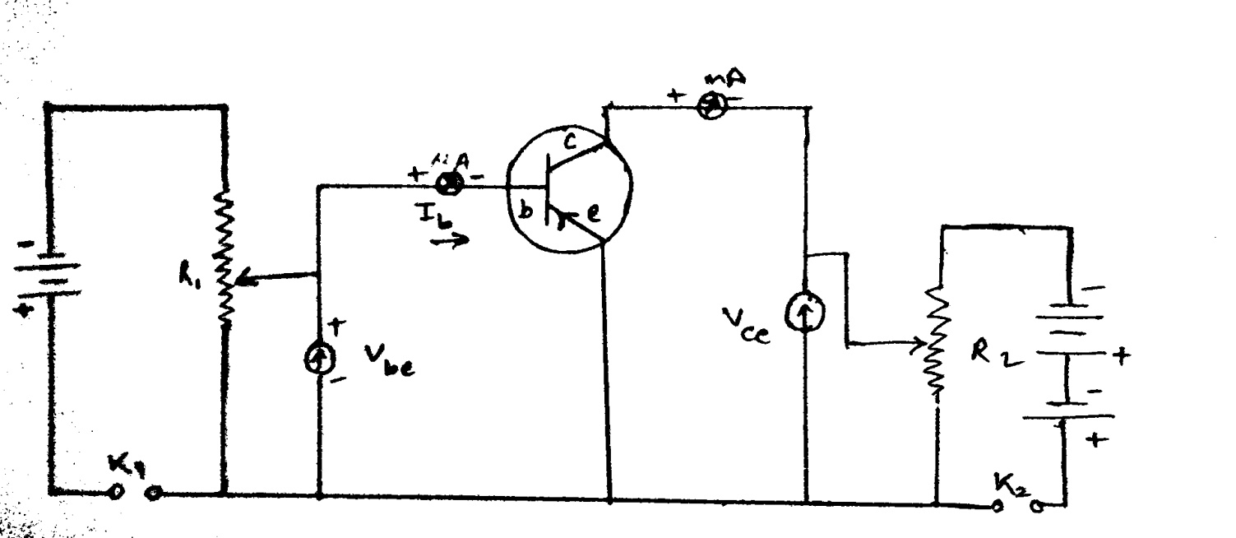

**CE mode of a PNP transistor**

**Theory:**

A Transistor is a semiconductor current operating device capable of giving current gain, voltage amplification and power gain, its operation depends upon the flow of electric charge carriers in the solid state. Characteristics in the graphical form are helpful in understanding the performance of transistor. The basic parameters of the transistor are emitter voltage ($V_{e})$, emitter current ($I_{e})$, collector voltage ($V_{c})$, collector current ($I_{c}$) and

$Characteristics Curves:$ The relation between input and output currents and voltages may be represented graphically known as characteristics curves.

In common emitter PNP junction transistor, emitter is made common to both the input and output circuit. Let $V_{be}$ and $V_{ce}$ represents the potential difference between base emitter and collector emitter respectively and let $I_{b}$ and $I_{c}$ are the base and collector current respectively. The input voltage $V_{be }$ and the output current $I_{c}$ are taken as dependent variables whereas the input current ${ I}_{b}$ and the output voltage $V_{ce}$ are taken as independent variables.

**Formulas used**: H- parameters of a transistor in CE configuration are-

1. **Input Impedance - $r_{i}={\left(\frac{∆V_{be } }{∆{ I}_{b}}\right)}_{at const V_{ce}}$**

Slope of input characteristic curve

1. **Output Impedance- $r_{o}={\left(\frac{∆V_{ce } }{∆{ I}_{c}}\right)}_{at const I_{b}}$**

Slope of output characteristic curve

**Instructions:**

1. Collector voltage must not exceed the breakdown voltage.
2. Never connect transistor directly to AC switch.
3. Least count of voltmeter = 0.1 V
4. Least count of micro ammeter = 5 μA
5. Take reading under instrument range.

**Procedure:**

Connect the circuit as per the diagram.

**INPUT CHARACTERISTICS**

1. Keep collector-emitter voltage (VCE) constant.
2. Now by varying base-emitter voltage (VBE), note down the readings of base current Ib.
3. Repeat above steps for different constant values of VCE.
4. Draw graph between VBE  and I­B.

**OUTPUT CHARACTERISTICS**

1. Now keep the value of base current I­b fixed.
2. Now by varying collector-emitter voltage (Vce), note down the readings of collector current Ic..
3. Repeat above steps for different constant values of I­b.
4. Draw graph between Vce and I­c taking them along X and Y-axis respectively.

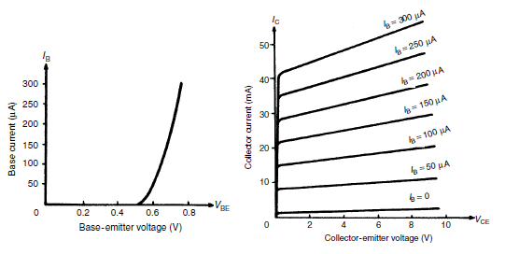

***Input Characteristics Curve* *Output Characteristics Curve***

**Observations:**

1. **Input characteristics**: At constant Vce = 0V,1V,2V,3V

|  |  |  |  |  |  |  |  |  |
| --- | --- | --- | --- | --- | --- | --- | --- | --- |
| **Sr. No.** | **Vce = V** | | **Vce = V** | | **Vce = V** | | **Vce = V** | |
| **Emitter Base voltage Vbe** | **Base current**  **Ib (μA)** | **Emitter Base voltage Vbe** | **Base current**  **Ib (μA)** | **Emitter Base voltage Vbe** | **Base current**  **Ib (μA)** | **Emitter Base voltage Vbe** | **Base current**  **Ib (μA)** |
| **1.** |  |  |  |  |  |  |  |  |
| **2.** |  |  |  |  |  |  |  |  |
| **3.** |  |  |  |  |  |  |  |  |
| **4.** |  |  |  |  |  |  |  |  |
| **5.** |  |  |  |  |  |  |  |  |
| **6.** |  |  |  |  |  |  |  |  |
| **7.** |  |  |  |  |  |  |  |  |
| **8.** |  |  |  |  |  |  |  |  |
| **9.** |  |  |  |  |  |  |  |  |
| **10.** |  |  |  |  |  |  |  |  |

1. **Output characteristics:** At constant Ib = 50 μA, 100 μA, 150 μA,…….

|  |  |  |  |  |  |  |  |  |
| --- | --- | --- | --- | --- | --- | --- | --- | --- |
| **Sr. No.** | **Ib= μA** | | **Ib= μA** | | **Ib= μA** | | **Ib= μA** | |
| **Collector Emitter voltage Vce** | **Collector current**  **Ic (mA)** | **Collector Emitter voltage Vce** | **Collector current**  **Ic (mA)** | **Collector Emitter voltage Vce** | **Collector current**  **Ic(mA)** | **Collector Emitter voltage Vce** | **Collector current**  **Ic (mA)** |
|  |  |  |  |  |  |  |  |  |
|  |  |  |  |  |  |  |  |  |
|  |  |  |  |  |  |  |  |  |
|  |  |  |  |  |  |  |  |  |
|  |  |  |  |  |  |  |  |  |
|  |  |  |  |  |  |  |  |  |
|  |  |  |  |  |  |  |  |  |
|  |  |  |  |  |  |  |  |  |
|  |  |  |  |  |  |  |  |  |
|  |  |  |  |  |  |  |  |  |



1. 

**RESULT:** h- parameters of a transistor in CE configuration are-

Input Impedance: - h11 = hie =

Output Admittance: - h22 = hoe =

**List of taken precautions:**

**Questions:**

1. Define transistor? What is the meaning of word TRANSISTOR?
2. Why a transistor is called as a bipolar junction transistor (BJT)?
3. How many terminals does a transistor have? Why base is kept very thin?
4. Draw the symbols for PNP and NPN transistors.
5. Discuss important applications of transistors

**EXPERIMENT NO. 2**

**Object: To study conversion of digital signals into analog signals using (D/A) converter.**

Roll No. .............................

# Date = ……………..

**Apparatus required: -** D/A converter kit, connection wires, multi meter, DC power supply.

**Theory: -**

Digital to analog (D/A) and analog-to-digital (A/D) conversion form two very important aspect of digital data processing. D/A conversion involve translating digital information into equivalent analog information. As an example, the output of a digital system might be changed to analog form for the purpose of driving a pen recorder. Similarly, an analog signal might be required for the servomotors, which drive the cursor arms of a plotter. In this respect, a D/A converter is sometimes considered a decoding device. The process of changing an analog signal to an equivalent digital signal is accomplished by the use of an A/D converter. For example, an A/D converter is used to change the analog output signals from transducers in to equivalent digital signals. These signals would then be in a form suitable for entry into a digital system. An A/D converter is often referred to as an encoding device since it is used to encode signals for entry into a digital system. D→A conversion is a straightforward process and is considerably easier than A/D conversion. In fact, a D/A converter is usually an integral part of any A/D converter. For this reason, we shall consider the digital-to-analog conversion process first.

**Variable resistor network**: - The basic problem in converting a digital signal into an equivalent signal is to change the n digital voltage levels into one equivalent analog voltage. This can be most easily accomplished by designing a resistive network which will change each of the digital levels into an equivalent binary weighted voltage (or current).

**Circuit Diagram: -**

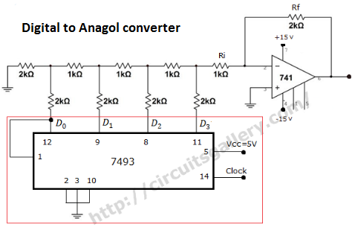

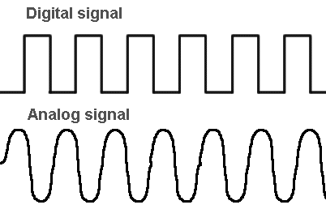 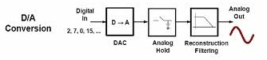

**Instruction:**

1. All the connection must be tight.

2. Readings of multi meter must be taken carefully.

3. Take reading under instrument range.

**Procedure:** Set the DC voltage with the help of digital multimeter near the 20V sockets (5V) side. Now proceed as per the truth table given below by using the table. You will find the difference in the voltage at the output. Tabulate the results in front of each column.

How to check the experiment: Change the position of switches A, B, C, D as per the table given and measure the output on output socket on digital multimeter. Complete the same as per given in the table (practical output)

**Observation table: -**

|  |  |  |  |  |  |  |
| --- | --- | --- | --- | --- | --- | --- |
| **S. No.** | **Digital input** | | | | **Practical output**  **(volts) Vo** | **Observed output**  **(volts) Vo** |
| **A** | **B** | **C** | **D** |
| 1 | 0 | 0 | 0 | 0 | -0.01 |  |
| 2 | 0 | 0 | 0 | 1 | -0.36 |  |
| 3 | 0 | 0 | 1 | 0 | -0.69 |  |
| 4 | 0 | 0 | 1 | 1 | -1.06 |  |
| 5 | 0 | 1 | 0 | 0 | -1.34 |  |
| 6 | 0 | 1 | 0 | 1 | -1.71 |  |
| 7 | 0 | 1 | 1 | 0 | -2.03 |  |
| 8 | 0 | 1 | 1 | 1 | -2.40 |  |
| 9 | 1 | 0 | 0 | 0 | -2.53 |  |
| 10 | 1 | 0 | 0 | 1 | -2.90 |  |
| 11 | 1 | 0 | 1 | 0 | -3.23 |  |
| 12 | 1 | 0 | 1 | 1 | -3.59 |  |
| 13 | 1 | 1 | 0 | 0 | -3.88 |  |
| 14 | 1 | 1 | 0 | 1 | -4.24 |  |
| 15 | 1 | 1 | 1 | 0 | -4.56 |  |
| 16 | 1 | 1 | 1 | 1 | -4.93 |  |



**Graph:**

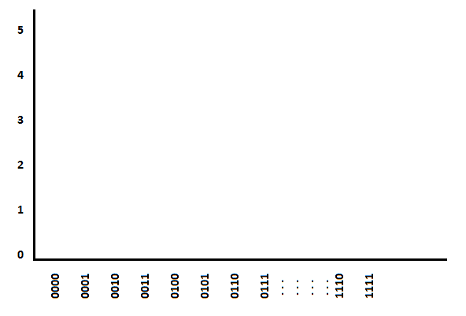

**Result:** Analog output signalobtained for the correspondingdigital signal.

**List of taken precautions:**

**Questions:**

1. Why conversion is required?
2. Differentiate between digital and analog instruments?
3. Why digital signals need to be converted to analog signals?
4. Write applications of D/A converter?

**EXPERIMENT NO. 3**

Roll No. .............................

# Date = ……………..

**Object: To study characteristics of a Field Effect Transistor (FET)**

**Apparatus required:** FET (n-channel), BFW 10 or equivalent, two independent DC low voltage sources ( 5V and 0 – 15 volts ), Voltmeter ( 0 – 2.5 volts and 0 -15 volts ), milliammeter ( 0 – 15 mA ).

**Theory:** The Field Effect Transistor or FET is a semiconductor amplifying device in which the output current is controlled by the input voltage, rather than by the input current as in the case of ordinary transistor. For this action the FET depends on only one kind of current carrier (electron or hole), It is therefore some time called ``unipolar’’ to distinguish it from the ordinary transistor which uses two types of current carriers and is called ``bipolar’’.

There are basically two types of FETs in regular use today. The most common is the junction field effect transistor of JFET, which has a direct Ohmic contact at the gate in the JFET. There are p and n channel type JFETs. The n-channel FET is very similar in voltage polarities and biasing to a vacuum tube triode.

Typically, a junction field effect transistor consists of a conducting channel enclosed for part of its length by a p-n junction. A theoretical basic structure and modern planar version of JFET are shown in figure. One end of the channel is called Source(S), the other end Drains (D) and the enclosing material that forms the junction, a Gate (G). These can be compared with the cathode, anode and grid respectively of an electron tube. If the channel is of n-type material as show in figure, the device is called an n-channel transistor; if the opposite arrangement is used; it is called a p-channel transistor.

The usefulness of the field-effect transistor is based on ability of the gate source potential to control the conductance of the channel and hence the current flow between the source and drain. Application of a reverse bias Vgs across the p-junction creates a space change, which partly depletes the channel of carriers and reduces its conductance. The bias value at which its conductance falls to zero is known as the pinch off voltage Vp.

**Circuit Diagram:**

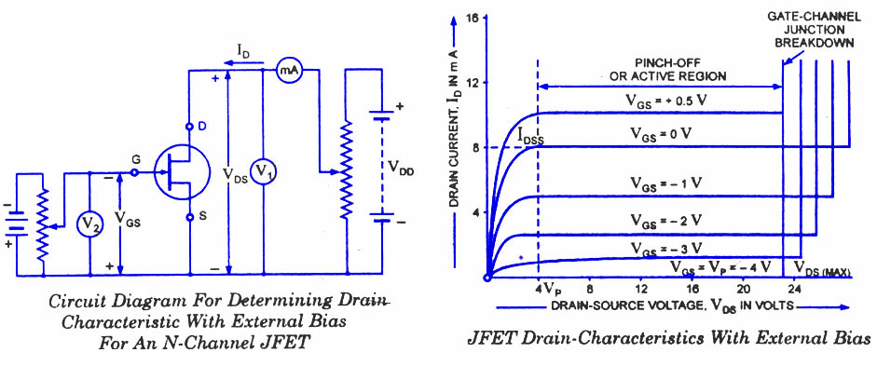

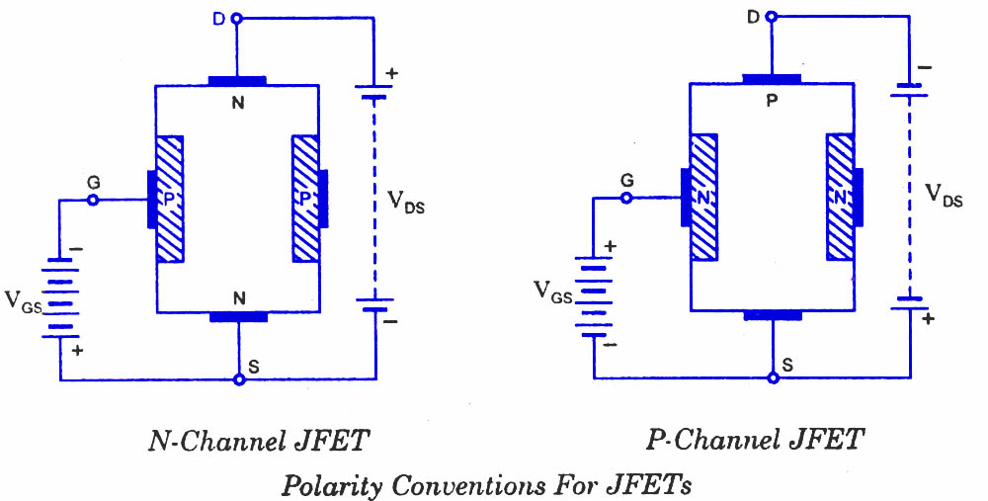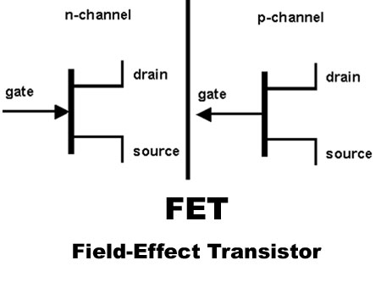

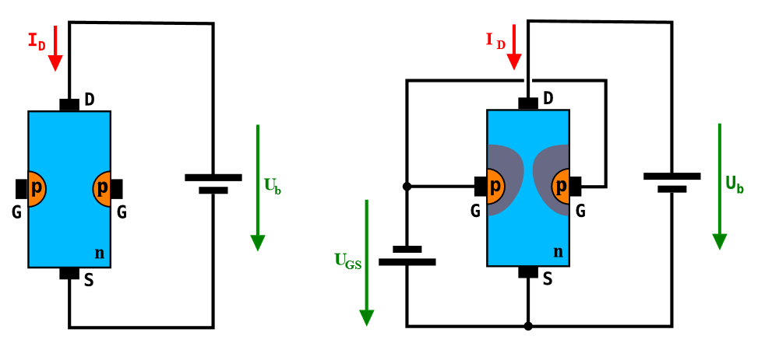

**Instructions:**

1. The three terminals of the FET must be carefully identified.

2. Practically FET contains four terminals, which are called source, drain, gate and substrate.

3. Source and gate should be short circuited.

4. Voltages exceeding the ratings of the FET should not be applied.

5. Take reading under instrument range.

**Procedure:**

**1). Output Characteristic**

(1) Adjust Vgs = 0V and very Vds in small step and for each value of Vds, note the drain current Id.

(2) Adjust Vgs to 0.1, 0.2, 0.3V...... or 0.2,0.4,0.6V..... or 0.5, 1.0, 1.5V..... and so on.

(3) Adjust Vds in small step and note drain current and draw the graph between Vds and drain current for every Vgs voltage.

**2). Transfer characteristic curve**

(1) Adjust Vds voltage in any constant value.

(2) Adjust Vgs in small step and note drain current and draw the graph between Vgs and drain current for constant Vds.

**Observation table : -(1) Output Characteristic**

|  |  |  |  |  |  |  |  |  |
| --- | --- | --- | --- | --- | --- | --- | --- | --- |
| **Sr. No.** | **Vgs = - Volts** | | **Vgs = - Volts** | | **Vgs = - Volts** | | **Vgs = - Volts** | |
| **Vds (volts)** | **Id**  **(mA)** | **Vds (volts)** | **Id (mA)** | **Vds (volts)** | **Id (mA)** | **Vds (volts)** | **Id (mA)** |
| **1** |  |  |  |  |  |  |  |  |
| **2** |  |  |  |  |  |  |  |  |
| **3** |  |  |  |  |  |  |  |  |
| **4** |  |  |  |  |  |  |  |  |
| **5** |  |  |  |  |  |  |  |  |
| **6** |  |  |  |  |  |  |  |  |
| **7** |  |  |  |  |  |  |  |  |
| **8** |  |  |  |  |  |  |  |  |
| **9** |  |  |  |  |  |  |  |  |
| **10** |  |  |  |  |  |  |  |  |



**2). Transfer characteristic**

|  |  |  |  |  |
| --- | --- | --- | --- | --- |
| **S. No.** | **Vds (volt) = …. V** | | **Vds (volt) = …. V** | |
| **Vgs (volt)** | **Id (mA)** | **Vgs (volt)** | **Id (mA)** |
| **1** |  |  |  |  |
| **2** |  |  |  |  |
| **3** |  |  |  |  |
| **4** |  |  |  |  |
| **5** |  |  |  |  |
| **6** |  |  |  |  |
| **7** |  |  |  |  |
| **8** |  |  |  |  |
| **9** |  |  |  |  |
| **10** |  |  |  |  |

Note: -Only one transfer characteristic curve is to be plotted on one graph paper.

**Graphs:** Output characteristic: Plot graphs of Id against Vds on constant Vgs, one graph paper.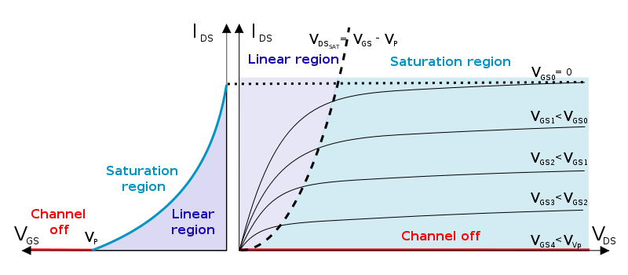

Transfer characteristic curve Output characteristic curve

**Transfer characteristic:** Plot graphs of Id against Vgs on a separate graph paper.



**Results:** The drain characteristics are similar tothat of a pentode value. The current is almost independent of drain voltage above `PINCH OFF’. The input resistance is essentially that of a reverse biased p-n (gate of source) junction, therefore is very high.

Transfer characteristic is similar to that of a vacuum triode.

**List of taken precautions:**

**Questions:**

1. What is a transistor?
2. What is an FET?
3. What are the three terminals of a FET?
4. Why FET is preferred over transistors?
5. FET is UJT or BJT? Explain?

**EXPERIMENT NO. 4**

Roll No. .............................

# Date = ……………..

**Object: To study output and transfer characteristics of a Metal Oxide Silicon Field Effect Transistor (MOSFET) and to identify the type of MOSFET.**

**Apparatus required:**  Trainer kit, connecting wires, power supply.

**Theory:** The Metal Oxide Silicon Field Effect Transistor (MOSFET) is a device with remarkable properties. It has input impedance greater than most vacuum tubes, a simple geometry inherently cheaper to fabricate than a junction transistor, essentially infinite current gain and extremely small size. Various designations of this device include IGEFT (insulated gate field effect transistor), etc. Its extreme high input impedance has opened new vistas for electronic circuits, particularly in ultra-sensitive electronic instruments, timing monitoring and various types of logic circuitry.

The MOSFET uses a metal gate electrode, which is separated from the channel by the insulating properties of thin layer of glassy silicon dioxide. Figure, as given below shows the theoretical basic structure and the modern planar version of a MOSFET. Like the p-n junction, this insulated gate electrode can deplete an adjacent channel of its active carriers when suitable bias voltages are applied.

In contrast with the junction gate operation, however, the conductivity of the depletion type MOS transistor channel can be substantially increased simply by reversing the polarity of the gate voltage. As a result of this unique characteristic, the input resistance remains high regardless of the signal voltage polarity. In additions the typical leakage currents associated with silicon dioxide insulator are relatively insensitive to temperature change and are many times small in magnitude than silicon junction leakage currents.

There are two modes of operation for MOSFETS; enhancement mode and depletion mode. The drain is biased positive with respect to the source. When the gate is shorted to the source, that is Vgs = 0, current flows through the channel, bulk resistance being the only limiting factor. As the drain current increases the voltage drop across the bulk of the channel makes the gate to channel getting more depleted near the drain and a stage is reached when further increase in drain to source voltage is compensated by the increase in channel resistance due to depletion of carriers resulting in no appreciable change in drain current. Then the channel is said to have been pinched-off. The source drain voltage at which the drain current does not increase further, is called pinch-off voltage.

A negative gate to source bias depletes the channel of the carrier thus reducing the drain currents. With negative bias, the extremely applied electric field adds on to the one produced by drain current and the channel is pinched off at a small drain currents. It is observed that the channel width is less near the drain because of the field developed by the channel resistive drop. Sufficient negative bias will remove all the current to flow between drain and source with positive bias applied to the gate. Electrons are attracted to the underside of the gate and thus channel conductivity is increased resulting in increased drain current.

**Circuit Diagram:**

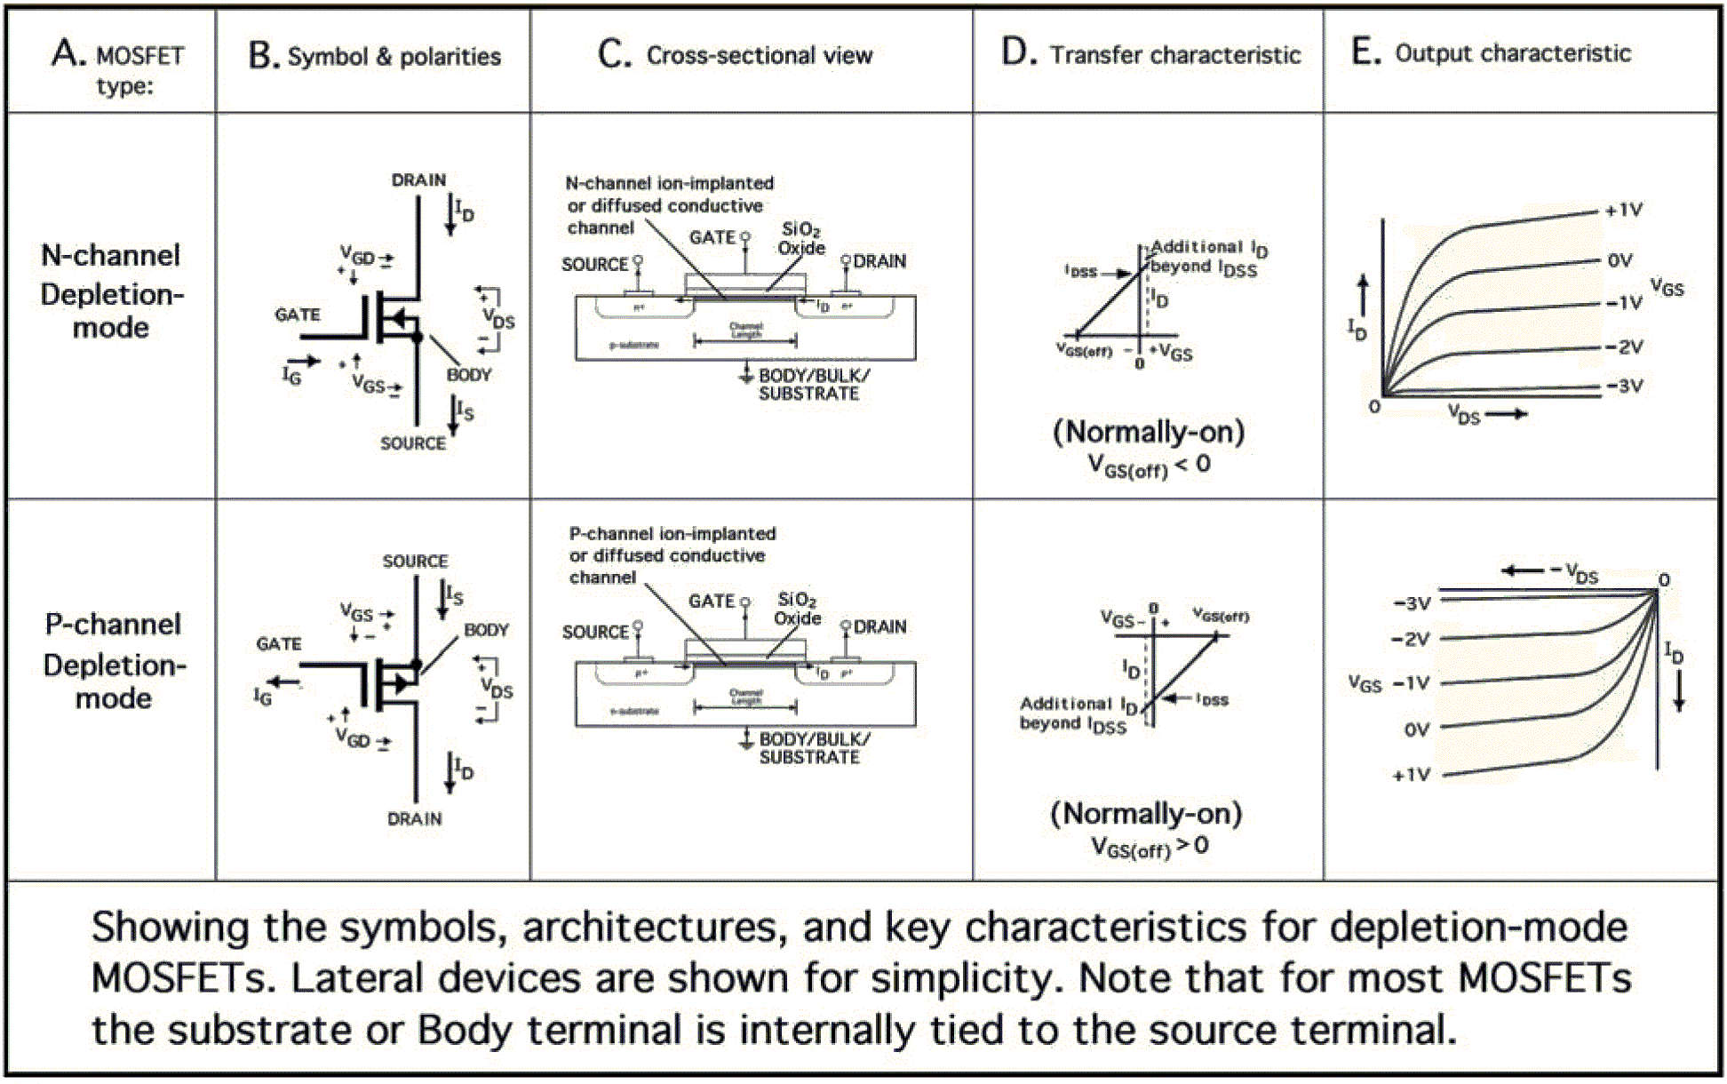

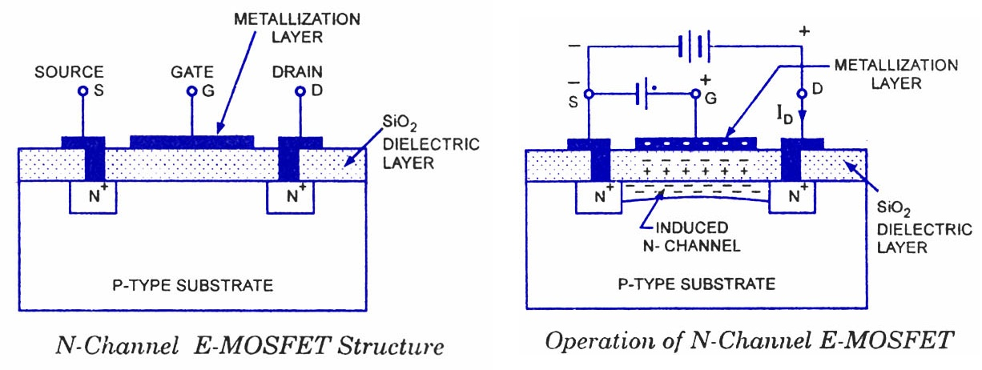

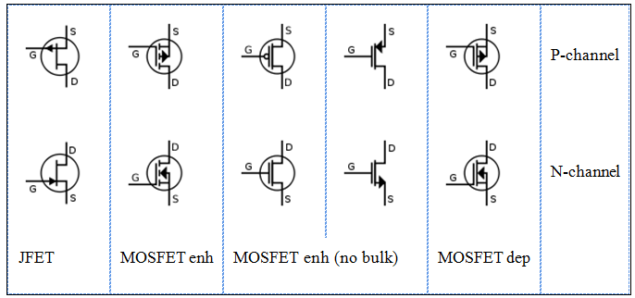

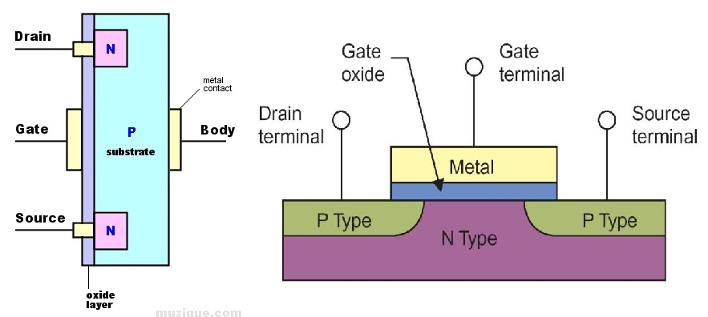

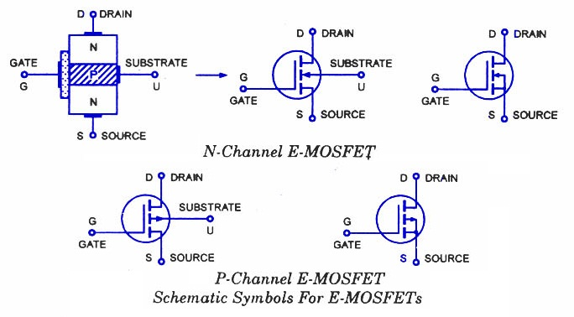

**Instructions:**

1. The three terminals of the MOSFET must be carefully identified.
2. Practically MOSFET contains four terminals, which are called source, drain, Gate, substrate.
3. Make connection carefully.
4. Take reading carefully.
5. Least count of Vgs = 0.1 V
6. Least count of ammeter = 0.5 mA (30 mA range)
7. Least count of Vds = 0.5 V
8. Least count of voltmeter = 0.5 V
9. Least count of miliammeter = 0.25 mA

10. Take reading under instrument range.

**Procedure:**

**Output Characteristics:**

1. Adjust Vgs so that output is obtained and then vary in small steps of 0.1 V.
2. Select switch 5mA or 25mA
3. Increase Vds in small steps and note down the values of drain current Id.
4. Again adjust to Vgs to 3.0, 3.1, 3.2, 3.3, 3.4 volts (only this value) and repeat step 3 and draw the graph between Id and Vds on constant value of Vgs.

**Transfer Characteristics:**

1. Adjust the Vds in any value (constant value).
2. Increase Vgs in small step and note the Id.
3. Put 5mA/25mA switch towards 25mA.

**Observation table**: Output characteristic

|  |  |  |  |  |  |  |
| --- | --- | --- | --- | --- | --- | --- |
| **S. No.** | **Vgs (volt) = …......Volts** | | **Vgs (volt) = …..... Volts** | | **Vgs (volt) = …..... Volts** | |
| **Vds (volt)** | **Id (mA)** | **Vds (volt)** | **Id (mA)** | **Vds (volt)** | **Id (mA)** |
|  |  |  |  |  |  |  |
| 1. |  |  |  |  |  |  |
| 2. |  |  |  |  |  |  |
| 3. |  |  |  |  |  |  |
| 4. |  |  |  |  |  |  |
| 5. |  |  |  |  |  |  |
| 6. |  |  |  |  |  |  |
| 7. |  |  |  |  |  |  |
| 8. |  |  |  |  |  |  |
| 9. |  |  |  |  |  |  |
| 10. |  |  |  |  |  |  |



**2) Observation Table:** Transfer characteristic

|  |  |  |  |  |
| --- | --- | --- | --- | --- |
| **S. No.** | **Vds (volt) = .....…. Volts** | | **Vds (volt) = …...... Volts** | |
|  | **Vgs (volt)** | **Id (mA)** | **Vgs (volt)** | **Id (mA)** |
|  |  |  |  |  |
|  |  |  |  |  |
|  |  |  |  |  |
|  |  |  |  |  |
|  |  |  |  |  |
|  |  |  |  |  |
|  |  |  |  |  |
|  |  |  |  |  |
|  |  |  |  |  |
|  |  |  |  |  |

**Graphs: Output characteristic:** Plot graph between Vds and Id keeping Vgs constant.

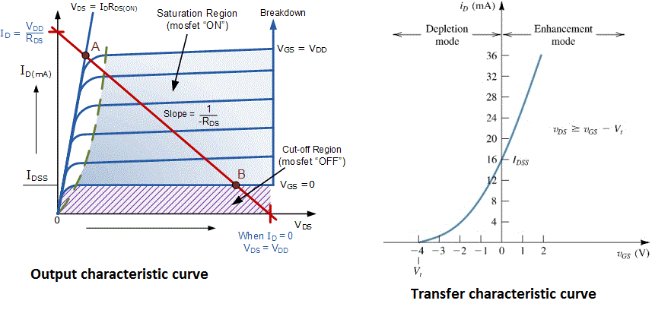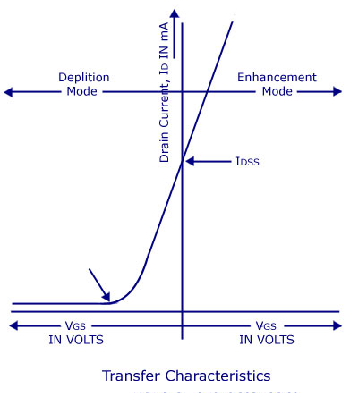

**Transfer characteristic:** Plot drain current Id against Vgs on a separate graph paper.



**Results:**

**List of taken precautions:**

**Questions:**

1. What is a MOSFET?
2. What is the difference between FET and MOSFET?
3. What are the three terminals of MOSFET?
4. How does current conduction take place in a MOSFET?

**EXPERIMENT NO. 5**

Roll No............................

# Date: ……………..

**Object: To study the V-I characteristics of a Uni-Junction Transistor (UJT).**

**Theory:** A Uni-Junction Transistor (UJT) is a three terminal semiconductor switching device. This device has a unique characteristic that when it is triggered, the emitter current increases regeneratively until it is limited by emitter power supply. Due to this characteristic, the Uni-Junction Transistor (UJT) can be employed in a variety of applications, such as switching. Pulse generator, saw tooth generator etc.

**Circuit Diagram:**

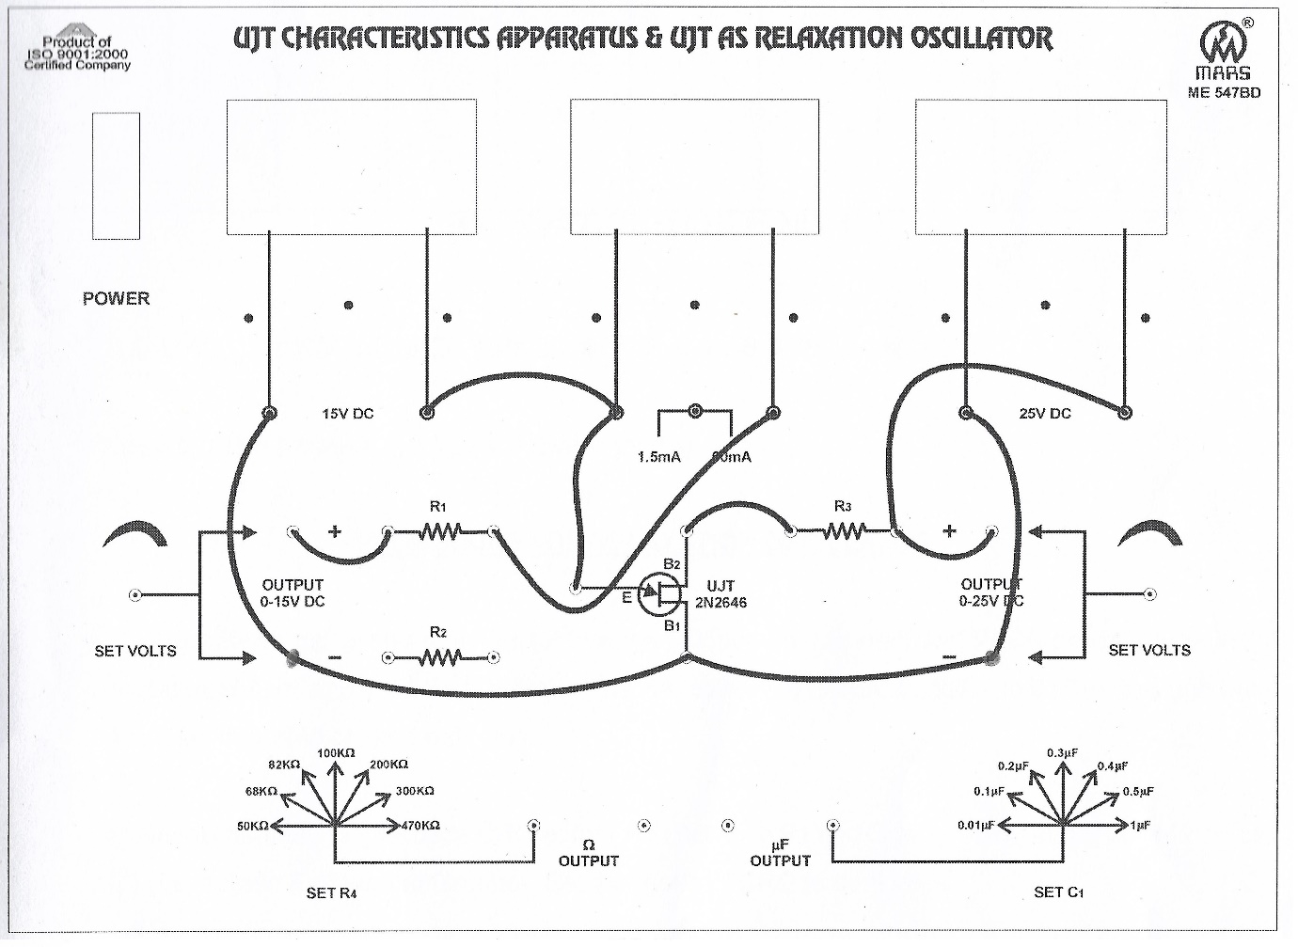

**Construction**: Fig (1a) shows the basic structure of a Uni-Junction Transistor (UJT). It consists of an n-type silicon bar with an electrical connection on each end. The leads of these connections are called base leads, Base-one B1 and base-two B2. Part way along the bar between the two bases, near to B2 than B1, a PN junction is formed between a P type emitter and the bar. The lead to this junction is called the emitter lead E. in fig. (1b) shows the symbol of unijunction transistor. It is noted from fig. (1a) that emitter is closer to B2 than B1. The following points are worth noting.

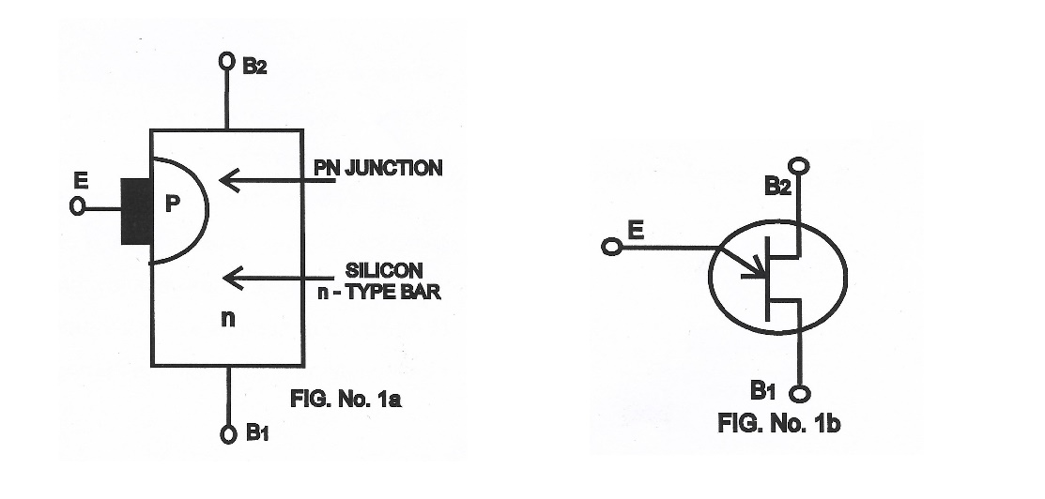

1. Since the device has one PN junction and three leads, it is commonly called a Uni-Junction Transistor (UJT).
2. With only one PN Junction the device is really a form of diode, because the two base terminals are taken from one section of the diode, this device is also called double-based diode.
3. The emitter is heavily doped having many holes. The n-region, however is lightly doped. For this reason, the resistance between the base terminals is very high (5KΩ to 10KΩ) when emitter lead is open.

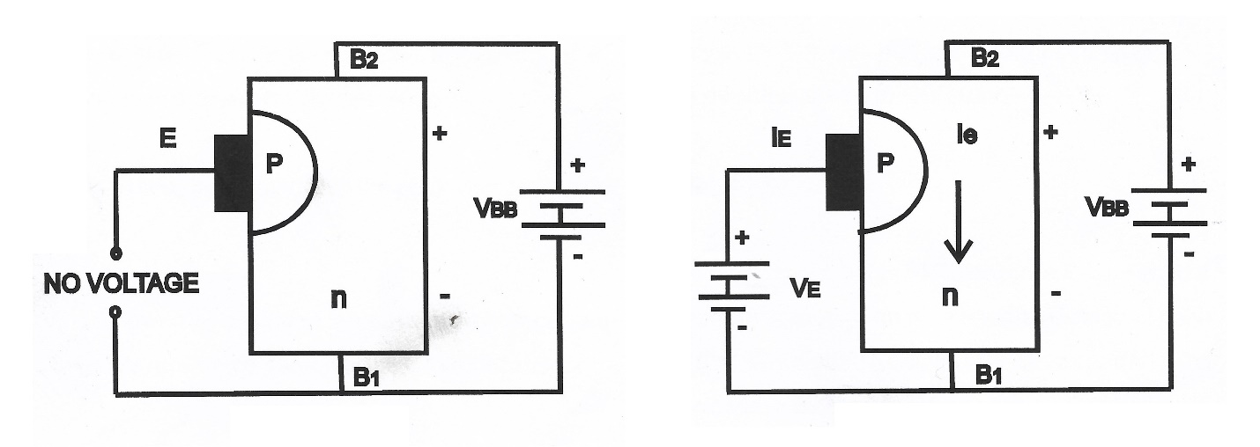**Operation:** Following figure shows the basic circuit operation of a unijunction transistor. The device has normally B2 positive w.r.t. B1.

1. If voltage VBB is applied between terminals B1 and B2 with emitter open as show in figure a voltage radiant is established along the n type bar. Since the emitter is located nearer t B2 more than half of the VBB appears between the emitter and B1. The voltage V1 between emitter and B1 establishes a reverse bias on the PN Junction and the emitter current is cut off. Of course a small leakage current flows from B2 to emitter due to minority carriers.
2. If a positive voltage is applied at the emitter as shown in figure, the PN Junction remains reverse biased so long as the input voltage is less than V1. If the input voltage to the emitter exceeds V1, the PN Junction becomes forward biased. Under these conditions holes are injected from P-type material into the n type bar. These holes are repelled by positive B2 terminal and they are attracted towards B1 terminal of the bar. This accumulation of holes in the emitter to B1 region results in the decrease of resistance in this section of the bar. The result is that internal voltage drop from emitter to B1 is decreased and hence the emitter current IE increases. As more holes are injected, a condition of saturation will eventually be reached. At this point the emitter current is limited by the emitter voltage or emitter power supply. The device is now in the ON state.

If a negative pulse is applied to the emitter, the p-n junction is reverse biased and the emitter is cut off. The device is then said to be in the off state.

**Procedure:**

* 1. Connect the dotted lines through patch cords as shown in the circuit of figure.
  2. Keep both the power supplies at zero potential.
  3. Switch ON the instrument using ON/OFF toggle switch provided on the front panel.
  4. Select the current meter range to 1.5 mA through SPDT switch.
  5. Adjust VB2B1 (voltage between B2 and B1) to 5VDC.
  6. Increase the value of VE (emitter voltage) in small steps and note down the corresponding value of IE (emitter current).
  7. Now change the milliammeter range to 60 mA and start increasing the value of VE, at a particular value of VE,IE current increases sharply with decrease in VE. Note down the value of VE at the instant. Note down the observation in Table
  8. Adjust VB2B1 at 10V, 15V and 20 volts, again repeat the 6 and 7th steps.
  9. Draw a graph between IE and VE as Shown in figure.

|  |  |  |  |  |  |  |  |  |
| --- | --- | --- | --- | --- | --- | --- | --- | --- |
| S.N. | VB2B1= | | VB2B1= | | VB2B1= | | VB2B1= | |
| VE | IE | VE | IE | VE | IE | VE | IE |
| 1 |  |  |  |  |  |  |  |  |
| 2 |  |  |  |  |  |  |  |  |
| 3 |  |  |  |  |  |  |  |  |
| 4 |  |  |  |  |  |  |  |  |
| 5 |  |  |  |  |  |  |  |  |
| 6 |  |  |  |  |  |  |  |  |
| 7 |  |  |  |  |  |  |  |  |
| 8 |  |  |  |  |  |  |  |  |
| 9 |  |  |  |  |  |  |  |  |
| 10 |  |  |  |  |  |  |  |  |

**Observation Table:**



**Characteristics of UJT:**  in figure shows the curve between emitter voltage (VE) and emitter current (IE) of a UJT at a given voltage VBB between the bases. This is known as the emitter characteristic:-

1. Initially, in the cutoff region, as VE increases from zero, slight leakage current flows from terminal B2 to the emitter. This current is due to the minority carriers in the reverse biased diode.
2. Above a certain value of VE, forward current IE begins to flow, increasing until the peak voltage VP and current IP are reached at point P.
3. After the peak point p, an attempt to increase VE is followed by a sudden increase in emitter current IE with a corresponding decrease in VE. Then negative portion of the curve because with increase in IE, VE decreases.
4. The negative portion of the curve lasts until the valley point V is reached with valley point voltage VV and valley point current IV. After the valley point, the device is to saturation.

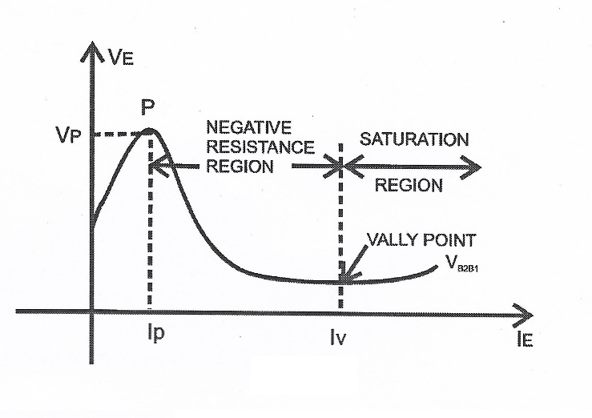

**List of taken precautions:**

**Questions:**

1. What do you mean by UJT?
2. What are various applications of UJTs?
3. Differentiate between BJT and UJT.
4. Define channel in a UJT.
5. How many regions does the input characteristic curve of a UJT have?

**EXPERIMENT NO. 6**

**Object: To study conversion of analog signal into digital signal using A/D converter.**

Roll No. =...........................

# Date = ……………..

**Apparatus required:** A/D converter kit (ADC 0808/09), connection wires, multi meter.

**Theory:** The process of changing an analog signal to an equivalent digital signal is accomplished by the use of an A/D Converter. In this system a continuous sequence of equally spaced pulses is passed is passed through AND gate. The gate is normally closed and is opened at the instant of the beginning of a linear sweep voltage. The gate remains open until the linear sweep voltage attains the reference voltage of the comparator, the level of which is set equal to the analog voltage to be converted. The number of pulses is proportional to the analog voltage. If the analog voltage varies with time, it will not be possible to convert the analog voltage continuously, but it will be required that the analog data be sampled at intervals. The maximum value of the analog voltage will be represented by a number of pulses. The clear pulse resets the counter to the zero count. The counter then records in binary form from the clock lines. The clock is a source of pulses spaced in time since the number of pulses counted increases linearly with time, the binary word representing this count is used as the input of a D/A converter. As long as the analog input V is greater than Vd the comparator output is high and the AND gate is open for the transmission of the clock pulses to the counter. When V exceeds Vd, the comparator output changes to the low value and the gate is disabled. This stops counting when Vs ~ Vd the counter can be read out as the digital word representing the analog input voltage.

**Circuit Diagram:**

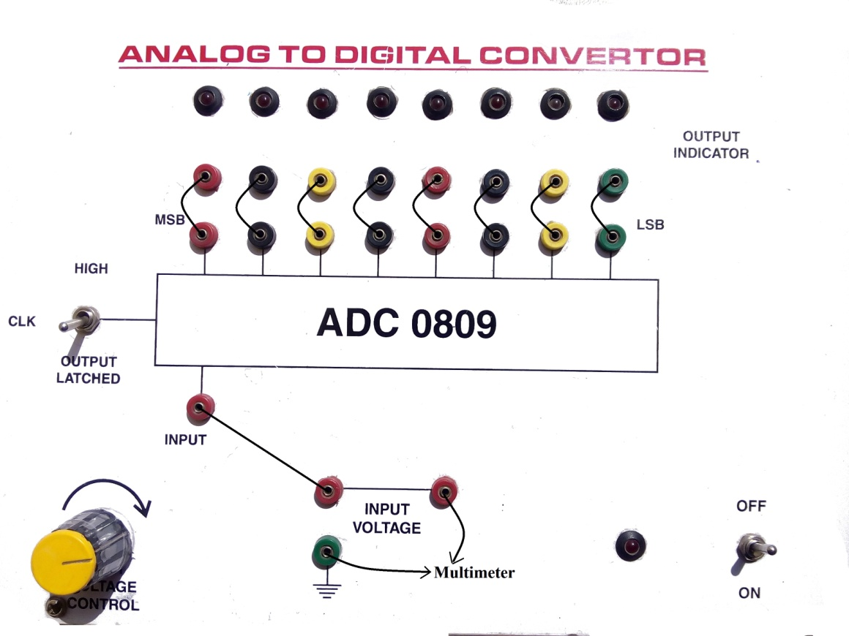

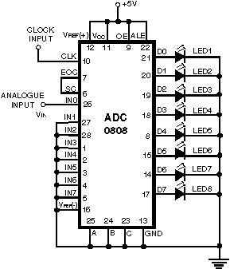 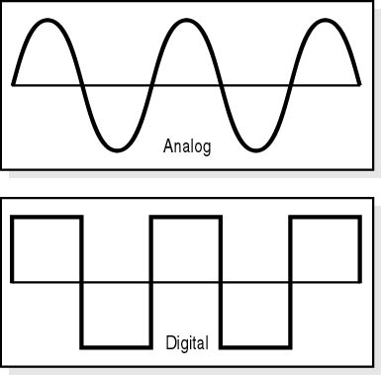

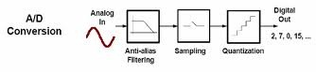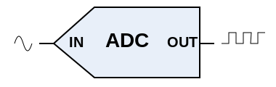

**Instructions:**

1) All the connections must be tight.

2). Readings of multi meter must be taken carefully.

3). Take the analog input voltage in a proper interval.

4) Take reading under instrument range.

**Procedure:**

1) Connect the o/p terminals (marked LSB to MSB) on the paned to the I/P terminal of all the LED’s one by one.

2). Turn ON the potentiometer knob to set DCV (0-20 volt) side.

3). Put the clock switch in the latched mode.

4). Connect IN marked socked to input voltage socket positive.

5). Switch on the power.

6). Measure the input voltage in multimeter and note it down.

7). Put the clock switch in the HIGH mode and note the status of the LED’s

(i). If the I/P voltage is zero, all LED’s are off.

(ii). If the I/P voltage is 5.0 volt, all the LED’s are on.

8). Now change the I/P voltage turning the potentiometer knob and note down the O/P and note down the O/P indicated in the form of Digital 8 bit O/Ps.

**Observation Table:**

|  |  |  |  |  |  |  |  |  |
| --- | --- | --- | --- | --- | --- | --- | --- | --- |
| **Analog input voltage** | **Digital output voltage** | | | | | | | |
| **H** | **G** | **F** | **E** | **D** | **C** | **B** | **A** |
| **0 V** | **0** | **0** | **0** | **0** | **0** | **0** | **0** | **0** |
| **0.5 V** |  |  |  |  |  |  |  |  |
| **1.0 V** |  |  |  |  |  |  |  |  |
| **1.5 V** |  |  |  |  |  |  |  |  |
| **2.0 V** |  |  |  |  |  |  |  |  |
| **2.5 V** |  |  |  |  |  |  |  |  |
| **3.0 V** |  |  |  |  |  |  |  |  |
| **3.5 V** |  |  |  |  |  |  |  |  |
| **4.0 V** |  |  |  |  |  |  |  |  |
| **4.5 V** |  |  |  |  |  |  |  |  |
| **5.0 V** | **1** | **1** | **1** | **1** | **1** | **1** | **1** | **1** |

**Graph:** Input analog voltage is plotted on the X-axis and the corresponding digital voltage is plotted on the Y-axis.

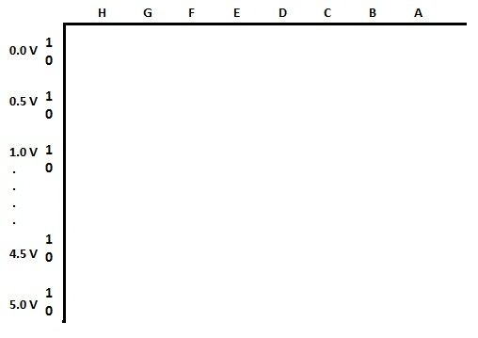

**Result:** Digital output signal obtained corresponding to input analog signal.



**List of taken precautions:**

**Questions:**

1. What is an A/D converter?
2. What are the applications of an A/D converter
3. How an A/D converter converts analog signal to digital signal?
4. What is the use of multimeter?

**EXPERIMENT NO. 7(A)**

**Object:** **To construct Hartley oscillator using a transistor and determine its frequency of oscillation and to compare it with theoretical value**

Roll No.=...........................

# Date = ……………..

**Apparatus Required:**

1. Transistorised power supply
2. Cathode ray oscilloscope (CRO) with calibrated time base/ frequency counter
3. connecting terminals

**Formula Used:**

The frequency of oscillation of the oscillator is given by

 Hz (L = 149 ± 10 μH )

where (=149±10 μH) is the resultant inductance of the series combination, and are self inductances of the two coils () and  is the capacitance of the condenser ().

**Circuit Description:** The Hartley oscillator is designed for generation of sinusoidal oscillations in the radia frequency (RF) range (20 KHz - 30 MHz). It is very popular and commonly used in radio receivers as a local oscillator. The circuit diagram of Hartley oscillator (parallel or shunt-fed) using BJT is shown in figure. It consists of an R-C coupled amplifier using an n-p-n transistor in CE configuration.  and are two resistors, which form a voltage divider bias to the transistor. A resistor RE is connected in the circuit which stabilizes the circuit against temperature variations. A capacitor CE connected in parallel with RE, acts as a bypass capacitor and provides a low reactive path to the amplified ac signal. The coupling capacitor CC blocks dc and provides an ac path from the collector to the tank circuit. The feedback network (tank circuit) consists of two inductors  and (in series) which are placed across a common capacitor and the centre of the two inductors is tapped as shown in figure. The feedback network (, and ) determines the frequency of oscillation of the oscillator.

**Theory:**

When the collector supply voltage  is switched on, collector current starts rising and charges the capacitor . When this capacitor is fully charged, it discharges through coils  and , setting up damped harmonic oscillations in the tank circuit. The oscillatory current in the tank circuit produces an a.c. voltage across which is applied to the base emitter junction of the transistor and appears in the amplified form in the collector circuit. Feedback of energy from output (collector emitter circuit) to input (base-emitter circuit is) accomplished through auto transformer action. The output of the amplifier is applied across the inductor , and the voltage across  forms the feedback voltage. The coil  is inductively coupled to coil , and the combination acts as an auto-transformer. This energy supplied to the tank circuit overcomes the losses occurring in it. Consequently the oscillations are sustained in the circuit.

The energy supplied to the tank circuit is in phase with the generated oscillations. The phase difference between the voltages across and that across is always 180° because the centre of the two is grounded. A further phase of 180° is introduced between the input and output voltages by the transistor itself. Thus, the total phase shift becomes 360° (or zero), thereby making the feedback positive or regenerative which is essential for oscillations. As a result, continuous undamped oscillations are obtained.

**Instructions:**

1. Check the continuity of the connecting terminals before going to connect the circuit.
2. Identify the emitter, base and collector of the transistor properly before connecting it in the circuit.
3. All connections should be neat and tight.
4. The horizontal length between two successive peaks should accurately be measured.

**Procedure:**

1. The circuit is connected as shown in figure.
2. Connect the CRO across the output terminals of the oscillator.
3. Switch on the power supply to both the oscillator and CRO.
4. Select proper values of , and in the oscillator circuit and get the sine wave form on the screen of CRO.
5. The voltage (deflection) sensitivity band switch (Y-plates) and time base band switch (X-plates) are adjusted such that a steady and complete picture of one or two sine waveform is obtained on the screen.

**Circuit diagram:**

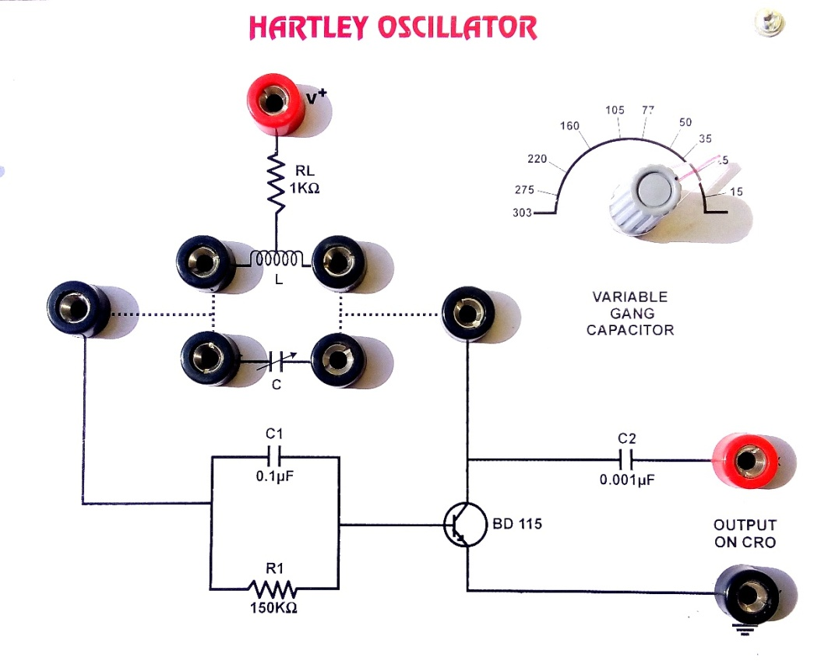

**Observations**: **L = 149±10 μH**

|  |  |  |  |  |  |  |
| --- | --- | --- | --- | --- | --- | --- |
| **S. No.** | **Capacitance (pF)** | **Measurement of Time Period** | | | **Frequency ()** | |
|  | **Peak to Peak (Horizontal) Length (Div) ()** | **Time-Base**  **(Sec/Div)**  **( μ or)** | **Time Period**  **() Sec.** |  |  |
| **1.** |  |  |  |  |  |  |
| **2.** |  |  |  |  |  |  |
| **3.** |  |  |  |  |  |  |
| **4.** |  |  |  |  |  |  |
| **5.** |  |  |  |  |  |  |
| **6.** |  |  |  |  |  |  |
| **7.** |  |  |  |  |  |  |
| **8.** |  |  |  |  |  |  |
| **9.** |  |  |  |  |  |  |
| **10.** |  |  |  |  |  |  |

**Model Waveform:**

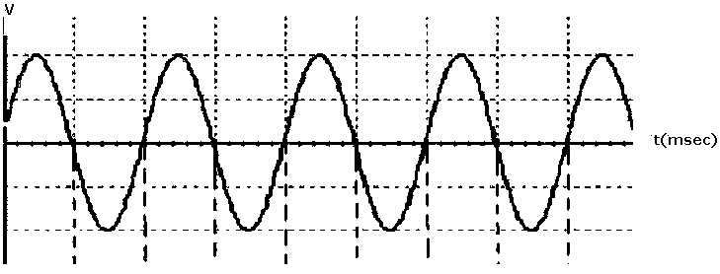

**Calculations:**

1. The horizontal length () between two successive peaks is noted.
2. When this horizontal length () is multiplied with the time base () i.e. sec/div, the time-period () is obtained.
3. The reciprocal of the time-period () gives the frequency ().
4. This can be verified with the frequency calculated theoretically by using the above formula.
5. The experiment is repeated by changing, or  or in C or all.
6. The readings are noted in the given table

**Results:** The theoretically calculated frequency =………….Hz

and the experimentally observed frequency=…………Hz

**List of taken precautions:**

**Questions:**

### Q.1 What are Hartley oscillators?

Q. 2 What is the principle of Hartley oscillator?

Q.3 What is the difference between the series-fed and the shunt-fed Hartley oscillator?

Q.4 What are advantages and disadvantages of Hartley oscillator?

Q.5 What are the disadvantages of LC oscillators over RC oscillators?

Q.6 What is CRO?

Q.7 What is the principle of CRO?

Q.8 What are the basic components of a CRO?

Q.9 What is the function of probe in CRO?

Q.10 How many types of probes are used in CRO?

Q.11 What are the functions of different probes used in CRO?

Q.12 Which device is used for the source of emission of electrons in a CRT?

Q.13 What is the function of electron gun used in CRT?

**EXPERIMENT NO. 7(B)**

Roll No.=...........................

# Date = ……………..

**Object**- To study of the wave shape and frequency produced by Colpitt’s Oscillator.

**Appratus Required:**  Power Cord , CRO(Cathod Ray Oscillioscope).

**The instrument comprises of the following built in parts:-**

1. Fixed output Regulated Power Supply of 12 Volts.
2. One medium Wave Frequency Coil is mounted inside the front panel.
3. Amplifier circuit consists of Transistor (CL 100), Inductance (50 mH), Resistance & Capacitors combination.
4. Tank circuit consists of medium wave frequency coil in parallel with capacitor.

**THEORY-**

Oscillator is an important device for many electronic circuit applications and its prime function is to generate wave forms at constant amplitude and desired frequency. Basically an oscillator is a electronic circuit which converts DC supply voltage to an output wave form of some frequency. The oscillator circuit must also be capable of producing sustained oscillations. The oscillators are classified into two basic categories: Sinusoidal and Non – Sinusoidal. If the wave form generated looks like sine wave, the circuit producing all other wave forms are called non – sinusoidal oscillators are also classified on the basis of frequency of the generated wave form, viz. Audio frequency, radio frequency oscillators.

Each oscillator has a tank circuit. This tank circuit consists of inductance coil (L) connected in parallel with capacitor (C). The frequency of oscillations in the circuit depends upon the value of the coil and capacitance of capacitor. The frequency of these oscillation is determined by the values of the C1 , C2 & L and is given by

**f = $\frac{1}{2π}$ $\left(L1C\right)1/2$**

**C = $\frac{c1/c2}{c1+c2}$**

**PROCEDURE**

1. Connect the CRO probes across output (X & Y Point) of the Colpitt Oscillator.
2. Swich ON the instrument as well as CRO.
3. Observe the output waveform on CRO and note down the frequency of oscillations. Formula used to circulate the frequency of oscillations

**f = $\frac{1}{2π}$ $\left(L1C\right)1/2$ when L = 2 $μH$**

Where C = $\frac{c1/c2}{c1+c2}$ C = 0.02 $μF$

Calculated value = 795 KHz

**Circuit diagram –**

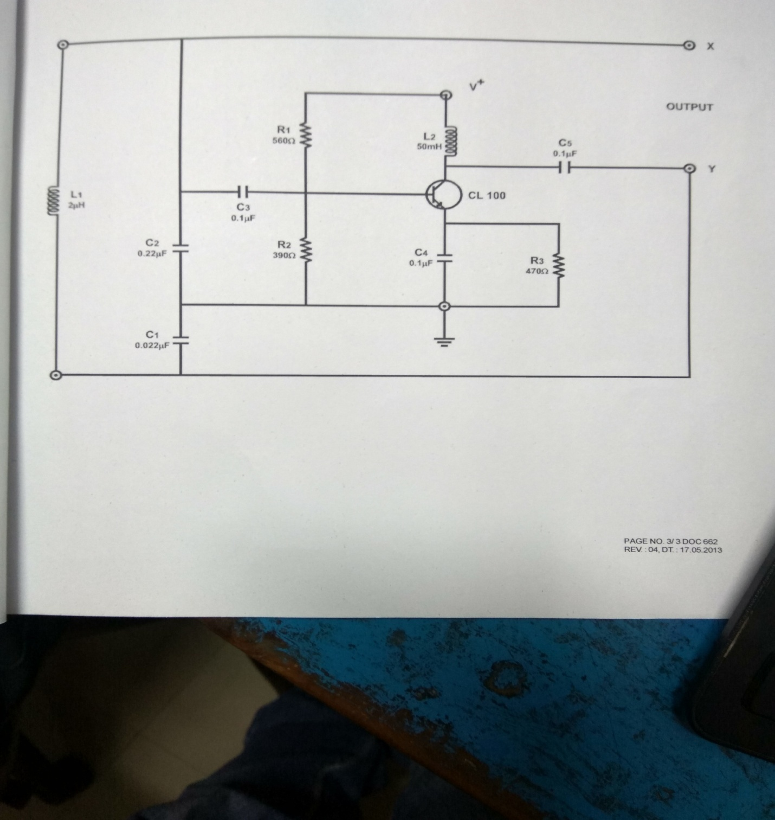

**SAMPLE OBSERVATION**

**NOTE:- These are observation of a particular instrument & may vary slightly from**

**piece to piece.**

1. Output Waveshape = Sine Wave, observed on CRO.

1. Amplitude = 4.8Vpp, observed on CRO.
2. Frequency = 793.1 KHz, observed on frequency counter.

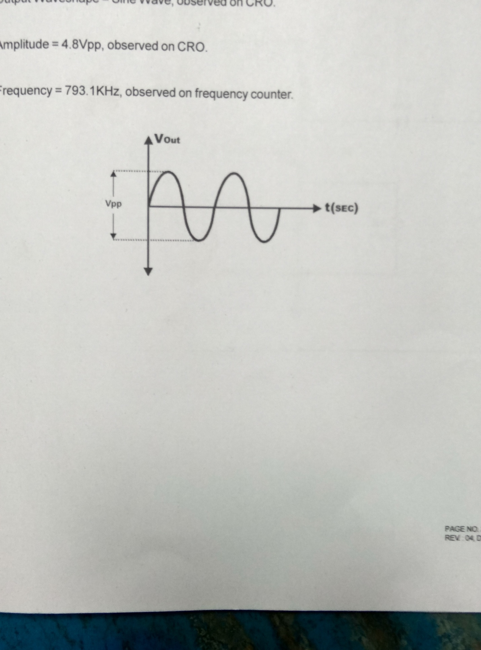

**Calculation-**

**List of taken Precaution –**



**Result-**

**Question:**

Q.1:- How Colpit Oscillator is different from Hartley Oscillator?

Q.2:- How the condition of “Positive Feedback” is achieved in Colpitt Oscillator?

Q.3:- What is advantage of Colpitt Oscillator over Hartley Oscillator at high

Frequency?

Q.4:- What is the use of Radio Frequency Choke Coil at the collector terminal of

Transistor in transistorised Colpitt Oscillator?

Q.5:- Can Op-Amp be used to fabricate Colpitt Oscillator instead of Transistor’s? If yes, what

the advantages of OP-AMP based Circuit.

**EXPERIMENT NO. 8**

Roll No.=...........................

# Date = ……………..

**Object:** To sketch the following basic op-amp circuits using ME 625 and verify them theoretically -

* 1. Inverting amplifier
  2. Non-inverting amplifier
  3. Differential amplifier
  4. Summing amplifier
  5. Integrator and differentiator

**Apparatus Required:**

a. Power supply: variable regulated low voltage dc source

b. Patch cord

c. Multimeter

**Theory:**

In this laboratory experiment, you will learn several basic ways in which an op-amp can be connected using –ve feedback to stabilize the gain and increase the frequency response. The extremely high open-loop gain of an op-amp creates an unstable situation because a small noise voltage on the input can be amplified to a point where the amplifier in driven out of its linear region. Also, unwanted oscillations can occur. In addition, the open-loop gain parameter of an op-amp can vary greatly from one device to the next. Negative feedback takes a portion of output and applies it back out of phase with the input, creating an effective reduction in gain. This closed-loop gain is usually much less than the open-loop gain and is independent of it.

**Closed – loop voltage gain:**

The closed-loop voltage gain is the voltage gain of an op-amp with external feedback. The amplifier configuration consists of the op-amp and an external –ve feedback circuit that connects the output to the inverting input. The closed loop voltage gain is determined by the external component values and can be precisely controlled by them.

**Inverting amplifier:**

An op-amp connected as an inverting amplifier with a controlled amount of voltage gain is shown in figure 1.



IC 741

**Figure 1: Inverting amplifier configuration of Op-amp**

The input signal is applied through a series input resistor R1 to the inverting input. Also, the output is fed back through Rf to the same input. The non-inverting input is grounded. An expression for the output voltage of the inverting amplifier is written as



The –ve sign indicates inversion. The closed-loop gain of the inverting amplifier is, thus



The input and output impedances of an inverting amplifier are



The output impedance of both the non-inverting and inverting amplifier configurations is very low; in fact, it is almost zero in practical cases. Because of this near zero output impedance, any load impedance connected to the op-amp output can vary greatly and does not change the output voltage at all.

**Operational requirements**

(i)Two variableDC regulated power supplies of 0-5 volts

(ii) One fixed output regulated power supply internally connected to IC 741.

(iii) Resistances with values 10 k, 22 k, 33 k and 47 kΩ.

(iv)Digital voltmeter

**Formula to be used**

If Vin and Vout are the input and output voltages, RF and R1 are feedback and applied resistances then output

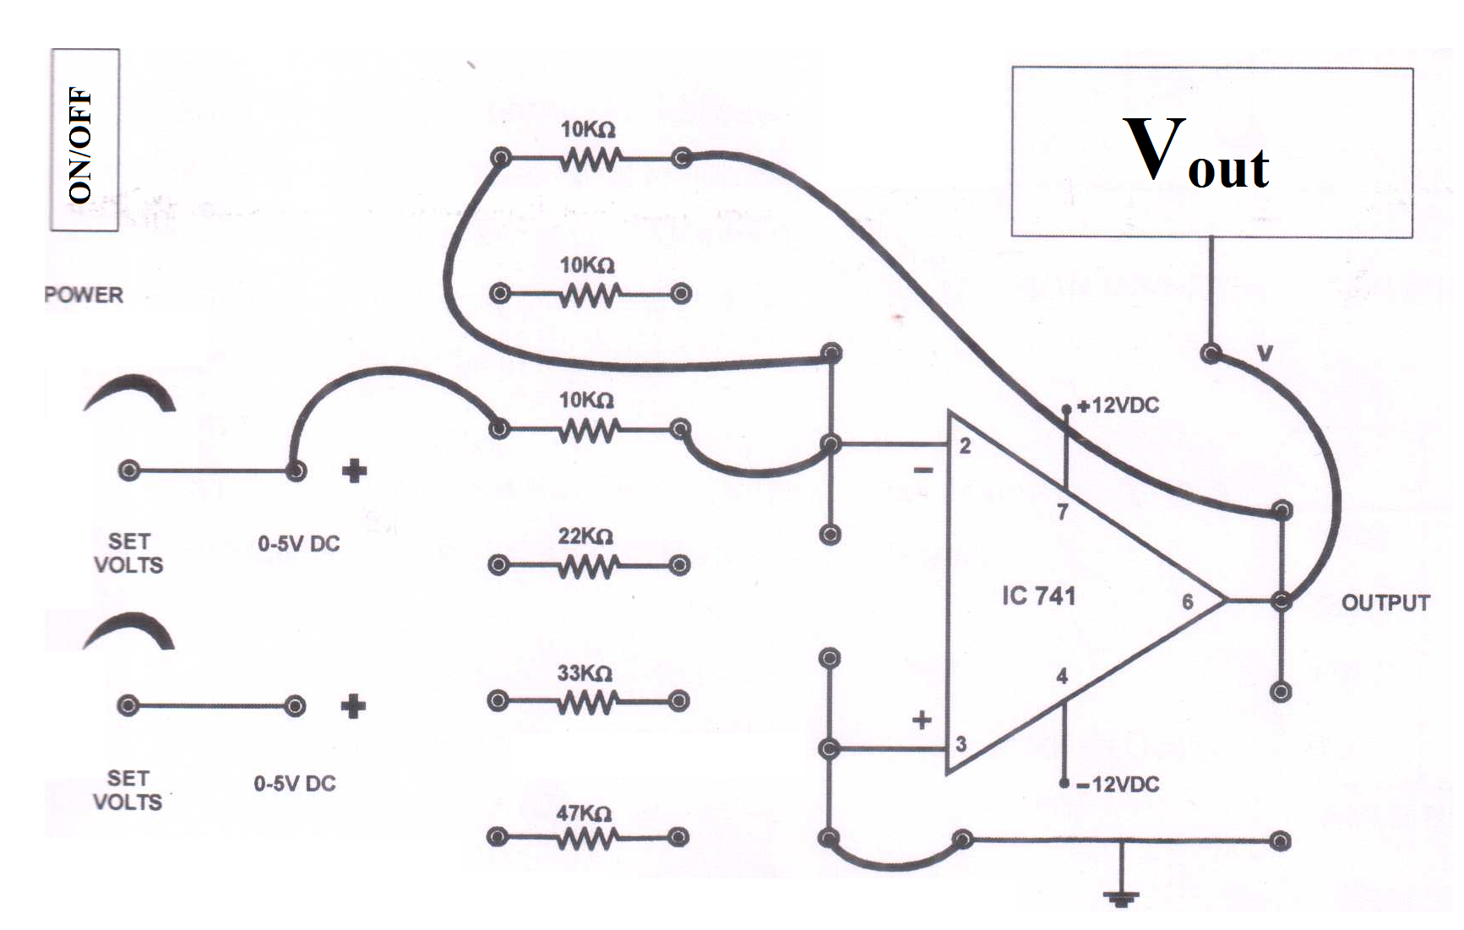  (1)

**Circuit connections:**

**Fig. 2**

**Instructions:**

1. Make all the connections properly and tightly.
2. While varying the value of RF, necessary care should be taken.
3. Voltages should not exceed the suggested values.
4. Resistances values are to be selected as selected.

(v) Voltage ratings are to be seen carefully.

**Working:**

(i) Switch the instrument ON using ON/OFF key provided on the front panel. For inverting amplifier any of the two power supplies is to be selected.

(ii) Connect the output of power supply to the input of digital voltmeter.

(iii) Adjust output of power supply to 1 volt DC using set volts knob and make the connections as per fig. above.

(iv)Now vary the value of feedback resistance RF and note the value of Vout for different values of R1 as per equation 1

**Observation Table 1**

*Vin =………..Volt*

|  |  |  |  |  |  |  |  |  |
| --- | --- | --- | --- | --- | --- | --- | --- | --- |
| R1 | *Vout* | | | | | | | |
| **RF =** 10 kΩ | | **RF =** 22 kΩ | | **RF =** 33 kΩ | | **RF =** 47 kΩ | |
|  | Experimental | Calculated | Experimental | Calculated | Experimental | Calculated | Experimental | Calculated |
|  |  |  |  |  |  |  |  |  |
|  |  |  |  |  |  |  |  |  |
|  |  |  |  |  |  |  |  |  |
|  |  |  |  |  |  |  |  |  |

**Calculation:**

**Result:**

The experimental values of output voltage (Vout) are similar to that calculated from equation 1.

**Non-inverting amplifier:**

An op-amp connected in a closed-loop configuration as a non-inverting amplifier with a controlled amount of voltage gain is shown in figure 2.



**Figure 3 Non-Inverting Amplifier Circuit Configuration of Op-amp**

**IC 741**

The input signal is applied to the non-inverting (+) input. The output is applied back to the inverting (-) input through the feedback circuit (closed loop) formed by the input resistor R1 and the feedback resistor Rf. This creates –ve feedback as follows. Resistors R1 and Rf form a voltage-divider circuit, which reduces VO and connects the reduced voltage Vf to the inverting input. The feedback is expressed as-



The difference of the input voltage, Vin and the feedback voltage, Vf is the differential input of the op-amp. This differential voltage is amplified by the gain of the op-amp and produces an output voltage expressed as -

.

**Operational requirements**

(i)Two variableDC regulated power supplies of 0-5 volts

(ii) One fixed output regulated power supply internally connected to IC 741.

(iii) Resistances with values 10 k, 22 k, 33 k and 47 kΩ.

(iv) Digital voltmeter

**Formula Used:**

If Vin and Vout are the input and output voltages, RF and R1 are feedback and applied resistances then the output in this configuration -

 (2)

**Circuit Connections**

|  |
| --- |
|  |

Fig. 4

**Working:**

(i) Switch the instrument ON using ON/OFF key provided on the front panel. For non-inverting amplifier any of the two power supplies is to be selected.

(ii) Connect the output of power supply to the input of digital voltmeter.

(iii) Adjust output of power supply to 1 volt DC using set volts knob and make the connections as per fig. above.

1. Now vary the value of feedback resistance RF and note the value of Vout for different values of R1 as per equation 2.

**Observation Table 2**

*Vin =………Volt*

|  |  |  |  |  |  |  |  |  |
| --- | --- | --- | --- | --- | --- | --- | --- | --- |
| R1 | *Vout* | | | | | | | |
| **RF =** 10 kΩ | | **RF =** 22 kΩ | | **RF =** 33 kΩ | | **RF =** 47 kΩ | |
|  | Experimental | Calculated | Experimental | Calculated | Experimental | Calculated | Experimental | Calculated |
|  |  |  |  |  |  |  |  |  |
|  |  |  |  |  |  |  |  |  |
|  |  |  |  |  |  |  |  |  |
|  |  |  |  |  |  |  |  |  |

**Calculation:**

**Result:**

The experimental values of output voltage (Vout) are similar to that calculated from equation 2.

**Summing amplifier:**

The summing amplifier is an application of the inverting op-amp configuration. The summing amplifier has two or more inputs, and its output is proportional to the algebraic sum of its input voltages. Figure 5 shows a two-input inverting summing amplifier.

***Case-1:*** If all the three resistors are equal (R1=R2=Rf=R) then



The above equation shows that the output voltage has the same magnitude as the sum of two input voltages but with a –ve sign indicating inversion.

***Case-2:*** When Rf is larger than the input resistors, the amplifier has a gain of (-*Rf/ R)* where R is the value of each equal value input resistor (R1=R2=R). The general expression for the output is



The above equation shows that the output voltage has the same magnitude as the sum of all the input voltages multiplied by a constant determined by the ratio (-*Rf/ R)*.

***Case-3:*** By setting the ration (Rf/R) equal to the reciprocal of the number of inputs (n), i. e., (Rf/R=1/n), a summing amplifier can be made to produce the mathematical average of the input voltages.

***Case-4:*** A different weight can be assigned to each input of a summing amplifier by simply adjusting the values of the input resistors. In this case, the output voltage can be expressed as



The weight of a particular input is set by the ratio of Rf to Rx for the input (Rx= R1, R2…)

**Operational requirements**

(i)Two variableDC regulated power supplies of 0-5 volts

(ii) One fixed output regulated power supply internally connected to IC 741.

(iii) Resistances with values 10 k, 22 k, 33 k and 47 kΩ.

(iv) Digital voltmeter

**Theory**

If Vin and Vout are the input and output voltages, RF and R1 are feedback and applied resistances then the output in this configuration -

 (3)

**Circuit diagram:**

|  |
| --- |
|  |

Fig. 5

**Circuit Connections:**

|  |
| --- |
|  |

Fig. 6

**Working:**

(i) Switch the instrument ON using ON/OFF key provided on the front panel. For summing amplifier both power supplies are to be selected.

(ii) Connect the output of power supply to the input of digital voltmeter.

(iii) Adjust output of both power supplies to 1 volt DC using set volts knob and make the connections as per fig. above.

(iv)Now vary the value of two input voltages and compare the theoretical value with practical valueas per equation 3.

**Observation Table 3**

|  |  |  |  |
| --- | --- | --- | --- |
| **VIN1** | **VIN2** | **Vout** | |
| Experimental | Calculated |
| 1 V | 1 V |  |  |
| 2 V | 2 V |  |  |
| 3 V | 3 V |  |  |
| 4 V | 4 V |  |  |

**Calculation:**

**Result**

The experimental values of output voltage (Vout) are similar to that calculated from equation 3.

**Difference amplifier:**

**Operational requirements**

(i)Two variableDC regulated power supplies of 0-5 volts

(ii) One fixed output regulated power supply internally connected to IC 741.

(iii) Resistances with values 10 k, 22 k, 33 k and 47 kΩ.

(iv)Digital voltmeter

**Theory**

If Vin and Vout are the input and output voltages, RF and R1 are feedback and applied resistances then the output in this configuration -

 (4)

**Circuit diagram**

|  |
| --- |
|  |

Fig. 7

**Circuit Connections**

|  |
| --- |
|  |

Fig. 8

**Working:**

(i) Switch the instrument ON using ON/OFF key provided on the front panel. For summing amplifier both power supplies are to be selected.

(ii) Connect the output of power supply to the input of digital voltmeter.

(iii) Adjust output of both power supplies to 1 volt DC using set volts knob and make the connections as per fig. 8 above.

(iv)Now vary the value of two input voltages and compare the theoretical value with practical valueas per equation 4.

**Observation Table 4**

|  |  |  |  |
| --- | --- | --- | --- |
| **VIN1** | **VIN2** | **Vout** | |
| Experimental | Calculated |
| 1 V | 1 V |  |  |
| 2 V | 2 V |  |  |
| 3 V | 3 V |  |  |
| 4 V | 4 V |  |  |

**Calculation:**

**Result:** The experimental values of output voltage (Vout) are similar to that calculated from equation 4.

**List of taken precautions:**

**Questions:**

(i) What is an operational amplifier?

(ii) What is integrated circuit?

(iii) What are inverting and non-inverting conditions of an operational amplifier?

(iv)What is a feedback amplifier?

1. What is Barkhausen criterion for self -maintained oscillations?
2. What is an oscillator?

(vii) What are the basic components of an operational amplifier?

(viii) What are positive and negative feedback amplifiers?

**EXPERIMENT NO.09**

Date.=...........................

Roll No.=...........................

**Object: To study the functioning of Lamp Block and characteristics of Phototransistor/Photodiode.**

**Apparatus required:** Fixed DC power supply +12Volts/150mA, Lamp Block and Photodiode/Phototransistor kit, 2multimeter for measuring current and voltage, connecting wires

**Theory:** Photo diode consists of a normal p-n junction housed in a small enclosure which a transparent window through which light can fall inside. Figure depicts photo diode symbol. A photo diode is operated in reverse bias in which leakage current increases in proportion to the amount of light falling on the junction. This is result of light energy which breaks the bonds in the crystal lattice of the semiconductor producing electrons and holes. This effect is similar to photo voltaic cell. Photo diodes are used as fast counters and used in light meters to measure the light energy.

A Phototransistor is an electronic switching and current amplification component which relies on exposure to light to operate. When light falls on the junction, reverse current flows which is proportional to the luminance. Phototransistors are used extensively to detect light pulses and convert them into digital electrical signals. These are operated by light rather than electric current.

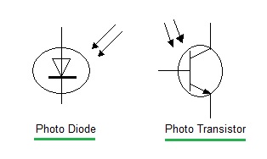

Fig. 1: Photodiode and phototransistor

It is capable of converting light energy into electric energy. Phototransistors work in a similar way to photo resistors commonly known as LDR (light dependant resistor) but are able to produce both current and voltage while photo resistors are only capable of producing current due to change in resistance. Phototransistors are transistors with the base terminal exposed. Instead of sending current into the base, the photons from striking light activate the transistor. This is because a phototransistor is made of a bipolar semiconductor and focuses the energy that is passed through it. These are activated by light particles and are used in virtually all electronic devices that depend on light in some way. All silicon photo sensors (phototransistors) respond to the entire visible radiation range as well as to infrared. The structure of the phototransistor is specifically optimized for photo applications. Compared to a normal transistor, a photo transistor has a larger base and collector width and is made using diffusion or ion implantation.

**Circuit Diagram:**

**(b)**

**(a)**

T11

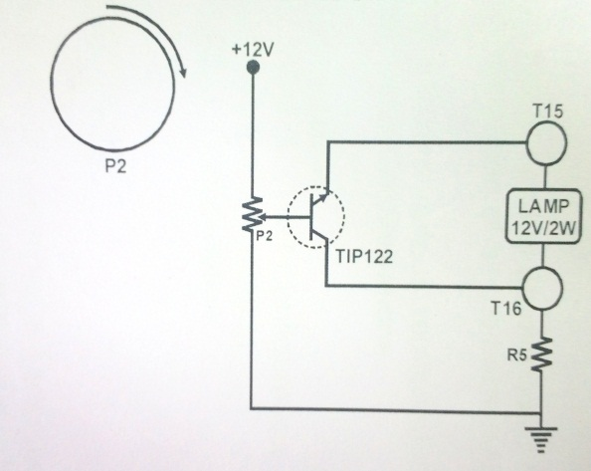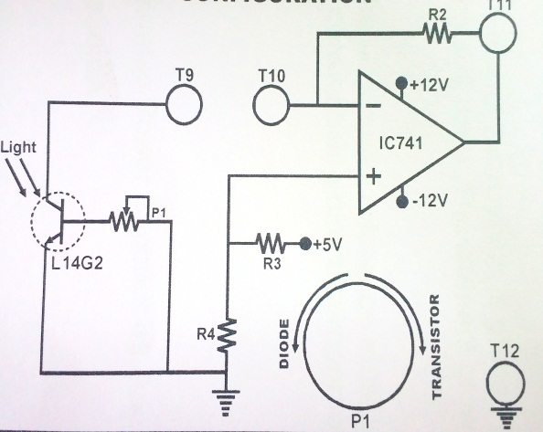

**Fig. 2:** Circuit diagram of **(a)** Lamp Block and, **(b)** Photodiode/phototransistor

**Procedure:**

1. **Functioning of Lamp Block:**
2. Connect the DC supply to the kit
3. Set a multimeter in the voltmeter mode, select 20V and connect (+) wire to theT15 and (-) wire to T16. **This is Voltage (VL)across the lamp**.
4. Adjust potentiometer P2 to minimum resistance to keep the voltage control knob of power supply to minimum position.
5. Switch ON the power.
6. Set the intensity control pot (P2) at minimum value so as to have zero output voltage across the lamp.
7. Now turn the pot to maximum side to obtain an increase of 1V step and hence the light intensity increases accordingly.
8. Note down the lamp voltage VL.
9. Set another multimeter in voltmeter mode, 2V DC and connect (+) wire to T16 and (-) wire to GND.
10. Measure the voltage across T16. The voltage measured directly gives the current value in amps as 1Ω resistance is connected in the series with the lamp. **This is current IL (V=IR) across the lamp**.
11. So lamp power and resistance can be calculated using following formula.
$$R_{L}= \frac{V_{L}}{I_{L}}$$

$$P_{L }=V_{L}×I_{L}$$

12. Repeat the same procedure for different value of lamp voltage.
13. Plot the graph of lamp power, lamp resistance against voltage applied to the lamp.

**Observation Table 1:**

|  |  |  |  |
| --- | --- | --- | --- |
| VL(Volts) | IL(mA) | RL(Ω) | PL(mW) |
| 1 |  |  |  |
| 2 |  |  |  |
| 3 |  |  |  |
| 4 |  |  |  |
| 5 |  |  |  |
| 6 |  |  |  |
| 7 |  |  |  |
| 8. |  |  |  |
| 9. |  |  |  |
| 10. |  |  |  |

1. **Characteristics of Phototransistor/Photodiode :**
2. Connect the DC supply to the kit
3. Set the multimeter in Ammeter mode, select 200mA and connect (+) wire to T9 and (-) wire to T10. This is current **IL**.
4. Set another multimeter in the voltmeter mode, select 20V and connect (+) wire to T11 and (-) wire to GND. This is voltage **VL**.
5. Switch ON the power supplies.
6. Observe the voltage at T10 i.e. at pin 2= 2V hence all the operation of circuit is taking place under constant VCE as a resultant variation in the photo current due to VCE is nil.
7. Initially keep the pot (P1) at maximum position i.e. device will act as phototransistor.
8. Take readings of output voltage at T11. Increase the lamp voltage by 1V
9. Now keep the sensitivity pot P1 at medium position. Take the readings.
10. Turn the sensitivity pot P1 to minimum position so it will act as photodiode. Take the readings adapting the same procedure.
11. Plot the graph of output voltage against Lamp power on the same graph paper for all the three different phototransistor sensitivity ranges.

**Note:** Subtract 2V from output voltage measured as that is the constant voltage maintained at inverting pin. The current value is same as voltage value (1K resistor).

**Observation Table 2:**

|  |  |  |  |  |
| --- | --- | --- | --- | --- |
| VL(Volts) | IL(mA) | PL(mW) | Pot max output voltage  (Phototransistor) | Pot min output voltage  (Photodiode) |
| 1 |  |  |  |  |
| 2 |  |  |  |  |
| 3 |  |  |  |  |
| 4 |  |  |  |  |
| 5 |  |  |  |  |
| 6 |  |  |  |  |
| 7 |  |  |  |  |
| 8. |  |  |  |  |
| 9. |  |  |  |  |
| 10. |  |  |  |  |

**Calculation:**

**Result:**

**List of taken precautions:**

**Questions:**

1. [What is the difference between photodiode and photocell?](https://www.quora.com/What-is-the-difference-between-photodiode-and-photocell)
2. [How do photodiode work?](https://www.quora.com/How-do-photodiode-work)
3. [Why is a photodiode reverse biased?](https://www.quora.com/Why-is-a-photodiode-reverse-biased)
4. [What is the difference between solar cell and photodiode?](https://www.quora.com/What-is-the-difference-between-solar-cell-and-photodiode)
5. [Why a phototransistor is reverse biased?](https://www.quora.com/Why-a-phototransistor-is-reverse-biased)
6. [What is the difference among LDR, photo resistor and photodiode?](https://www.quora.com/What-is-the-difference-among-LDR-photo-resistor-and-photodiode)
7. [Why the photocurrent in phototransistor larger than that in photodiode?](https://www.quora.com/Why-the-photocurrent-in-phototransistor-larger-than-that-in-photodiode)

**EXPERIMENT NO. 10**

Roll No............................

# Date ……………..

**Object:** To study the output gain, output power and frequency response of a push pull amplifier.

**Apparatus Required:** DC regulated power supply, Push pull amplifier circuit, connecting wire.

**Diagram:**

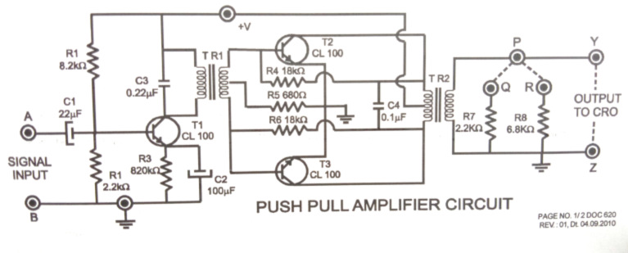

**Theory:** Push pull amplifier is a power amplifier and is frequently employed in the output stage of electric circuits. It is used whenever high output power at high efficiency is required. In the circuit of push pull amplifier, two transistor placed back to back are employed. Both transistor are operated in class B operation i.e collector current is nearly zero in the absence of the signal. The centre tapped secondary of driver transformer TR, supplied equal and opposite voltage to base circuit of two transistors. The output transformer TR2 has the centre-tapped primary winding. The supply voltage Vcc is connected between the based and this centre tap. The output load is connected across the secondary of this transformer.

Input signal appears across the secondary of driver transformer. Suppose during the first half cycle of the signal, one end becomes positive and the other end negative. This will make the base emitter junction of one transistor reverse biased and that of other forward biased. The circuit will conduct current due to T3 only. Therefore, this half cycle of the signal is amplified by T3 only, and appears in the lower half of primary of the output transformer. In the next half cycle of signal, T2 is forward biased whereas T3 is reversing biased. Therefore T2 conducts consequently this half cycle of the signal is amplified by T2 and appear in the upper half of the output transformer primary. The centre tapped primary of output transformer combines two collector current to form a sine wave in secondary. It may be noted here that the push pull arrangement also permits a maximum transfer of power to the load through impedance matching.

**Procedure:**

1. Connect audio frequency function generator across input sockets and set it at sine wave signal of 5 mV-10 mV peak to peak amplitude, 1 KHz frequency.
2. Connect CRO across output sockets.
3. Switch on the instrument using ON/OFF toggle switch provided on the front panel.
4. Observe the amplified output at CRO. Note down the output amplitude.
5. Calculate the voltage gain of the amplifier using formula Av =Vout/Vin
6. Increase the frequency of the signal of the signal towards 100 KHz in small step and note down the voltage gain at different frequencies.
7. Note down the observation in table1 and plot graph between voltage gain Vs frequency.
8. Connect the load resistance (R7 or R8) across output sockets and calculate the output power by using the formula P = V2/R (V is RMS value of output signal).

**Observation Table 1**

|  |  |  |  |  |
| --- | --- | --- | --- | --- |
| Sr. No. | Frequency | Input signal(Vmv) | Output signal (Vv) | Gain Vout/Vin |
| 1 |  |  |  |  |
| 2 |  |  |  |  |
| 3 |  |  |  |  |
| 4 |  |  |  |  |

**Calculation:**

Voltage gain Av =Vout/Vin

Output Power P = V2/R (V is the RMS value of output signal)

Then the **RMS voltage** (V**RMS**) of a sinusoidal waveform is determined by multiplying the peak **voltage** value by 0.7071, which is the same as one divided by the square root of two (1/√2).

**Result**:-Voltage gain of push pull amplifier....................

Power of push pull amplifier..............................

**Precaution:**

**Questions:**

1. **What is push-pull Amplifier?**
2. **What are the types of amplifier?**
3. **What are the ideal input and output resistances of various amplifier.**
4. **What is power amplifier?**
5. **How does an amplifier work in the circuits?**
6. **What is universal gate?**
7. **Why NAND & NOR are called universal gate?**
8. **What is logic gate?**
9. **What is truth table?**